# What you will need:

1 x Arduino Board

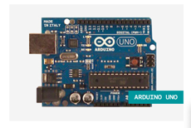

1 x Solderless Breadboard

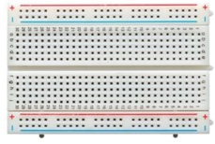

3 x 1Mom Resistor

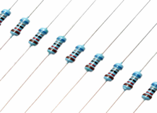

3 x Momentary Push To Make Buttons -(Red, Yellow, Green)

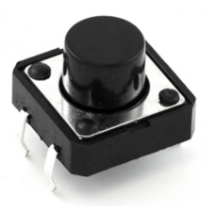

1 x USB 2.0 cable, Type A / B

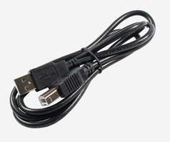

6 x Solderless (male to male) Breadboard Jumper Cables

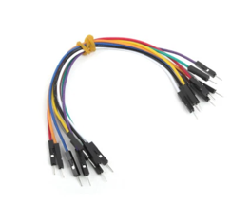

# How to build your own – (Configuring the hardware)

**Step 1:**

Download and install, then open Arduino IDE on your computer. (Software can be found at: <https://www.arduino.cc/en/Main/Software>)

**Step 2:**

Connect Arduino board to the computer using the USB cable (Type A/B)

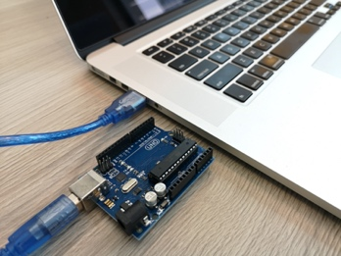

**Step 3:**

Configure Arduino by uploading Serial_Print.ino to the board. (this can be downloaded from GitHub)

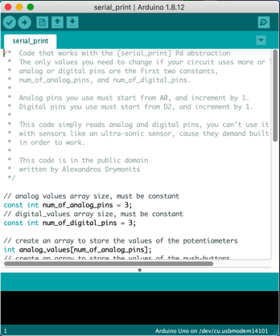

**Step 4:**

Connect the Momentary push buttons to the Breadboard and the 1mom resistors in the sequence as displayed

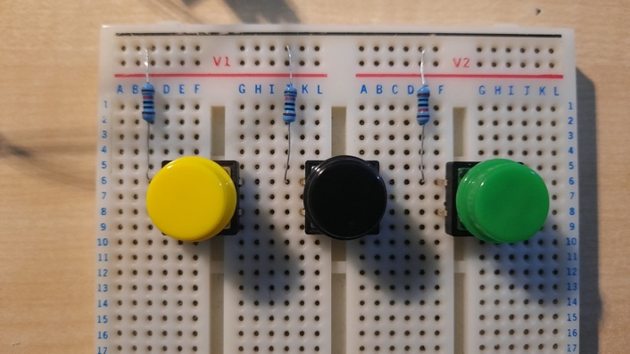

**Step 5:**

Connect the ground (GND) from the Arduino to the negative (black) strip on the breadboard using solderless male to male jumper cables. Connect the power (5V) from the Arduino to the positive (red) strip on the breadboard.

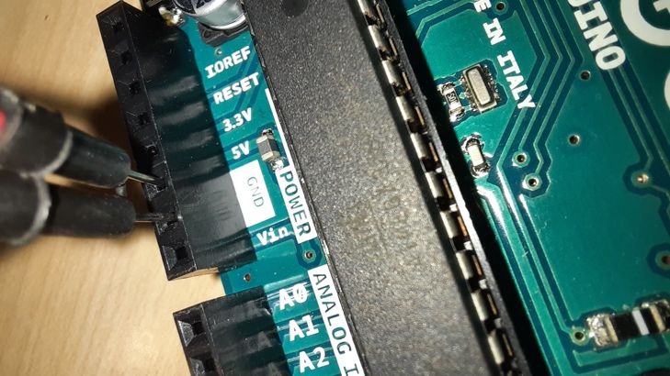 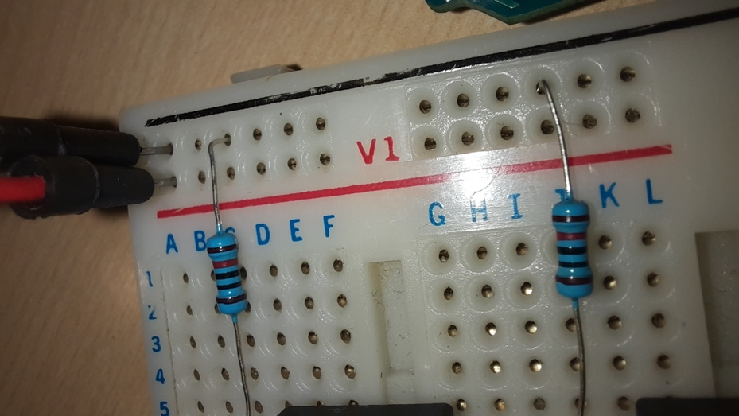 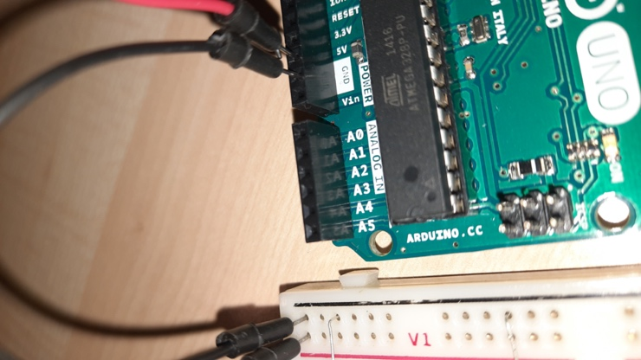

**Step 6:**

Insert a jumper cable next to the jumper cable carrying the 5V from the Arduino to the breadboard. Insert the other end of the jumper cable next to the Momentary button as displayed.

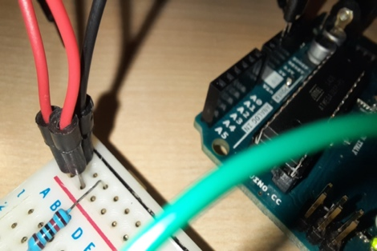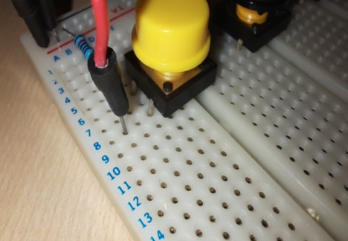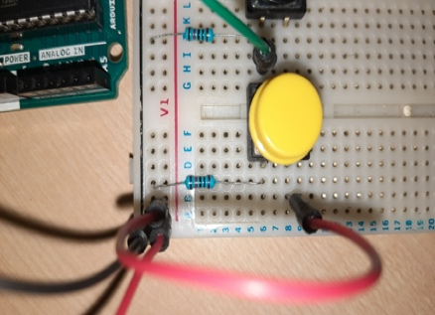

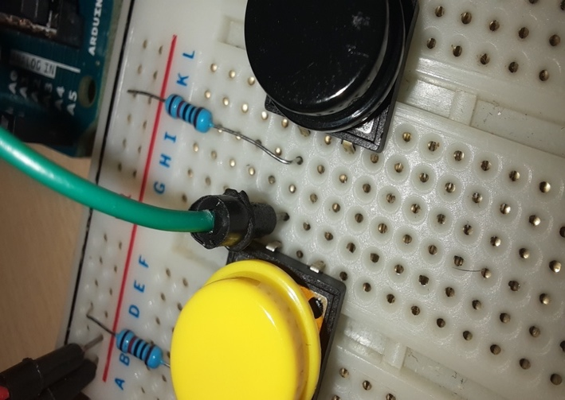**Step 7:** Connect a jumper cable next to the momentary button in order to carry the signal from the button to the analogue input of the Arduino. Repeat this step for the other two buttons.

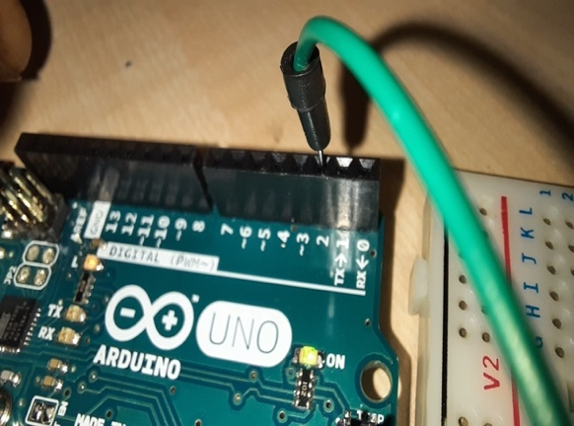

**Step 8:** The final setup should look like the image displayed with all the momentary buttons supplied with 5V and an analogue output connected to the Arduino. Connect to computer using USB Cable.



 